ME 396: CML A7 GAN Journey

This is a journey inspired by the short story “The Egg” by Andy Weir. I made this journey with Max Woolf’s VQGAN + CLIP colab, link below. All scenes generated were made using a seed number of 42.

<https://colab.research.google.com/drive/1wkF67ThUz37T2_oPIuSwuO4e_-0vjaLs?usp=sharing#scrollTo=clJsMT0Eqizk>

Scene 1

Prompt: “man dying in a car accident by Claude Monet”

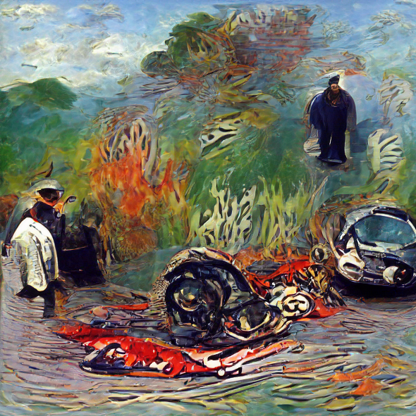

A car accident killed a man. But it also cut down a family. His wife and children were left to fend for themselves.

Scene 2

Prompt: “man meeting God by Claude Monet”

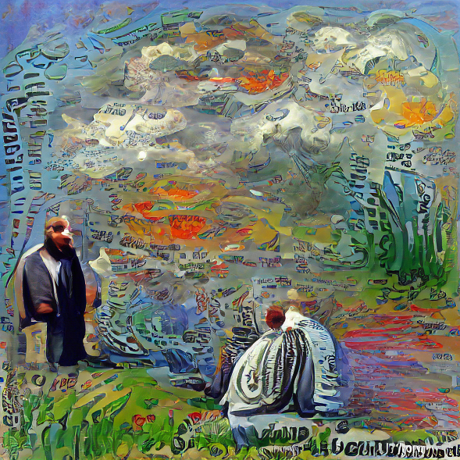

After his death, the man expected to meet God as his religion taught him. He expected to go live on in the afterlife.

Scene 3

Prompt: “man speaking with his grammar school teacher by Claude Monet”

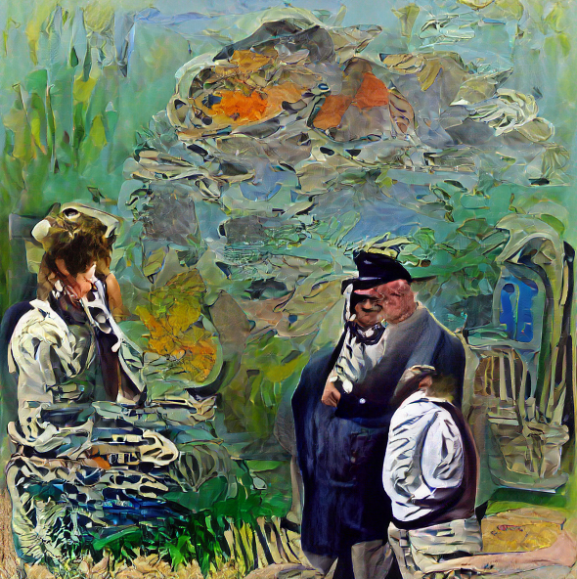

But the man met someone who did not look like a god. Instead, the man was speaking to someone that reminded him of one of his old school teachers.

Scene 4

Prompt: “wife and kids at funeral by Claude Monet”

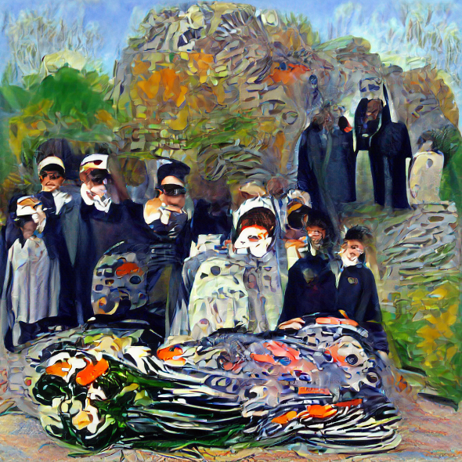

The man asks how his family is faring without him. At the funeral, the wife is both relieved and in grief over his death. The children remember him as a good father. They live a good life without him.

Scene 5

Prompt: “man asking for the meaning of life by Claude Monet”

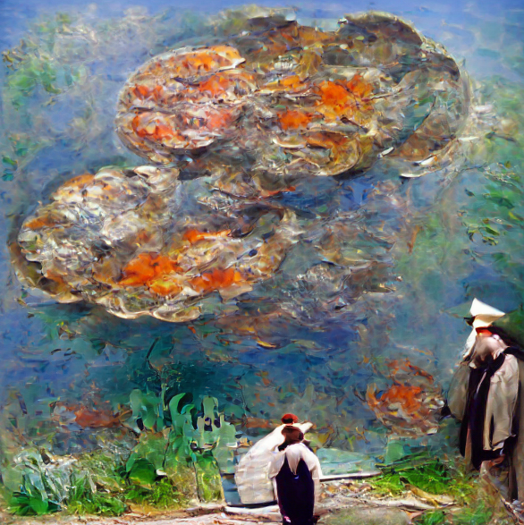

After understanding that his family will be okay, the man asks for the meaning of life. The god explains that the universe was made for him to mature.

Scene 6

Prompt: “Abraham Lincoln giving a speech by Claude Monet”

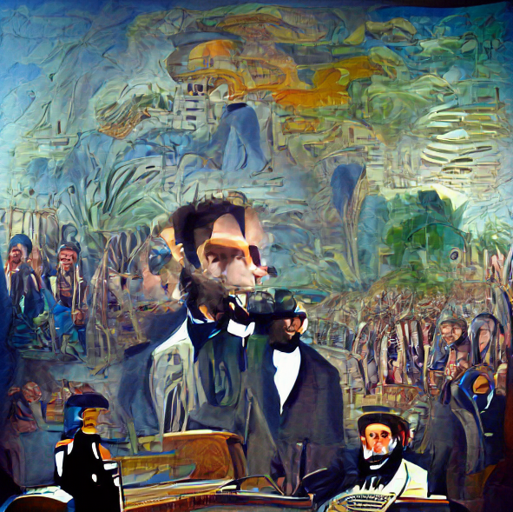

The god says that every individual in the history of humankind has been him. Every time he interacted with someone else, it was him.

Scene 7

Prompt: “small child by Claude Monet”

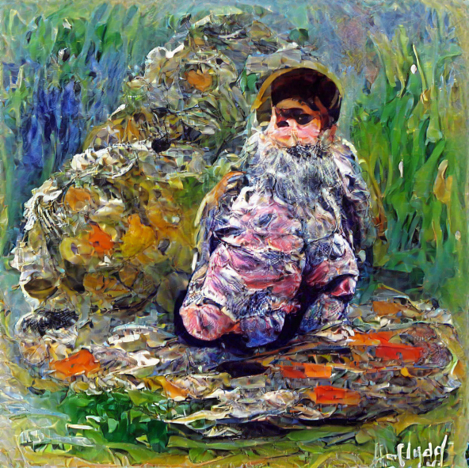

After this chat, it is time for the man to continue to mature by being reborn as a child and living another one of his lives.